August
2022 | 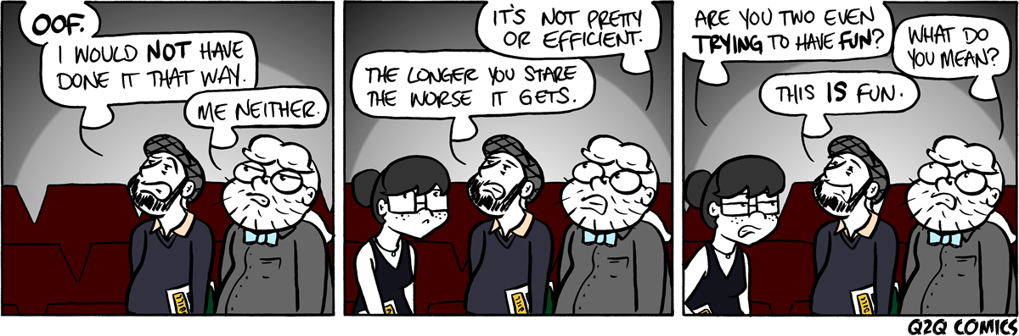
Sunday | Monday | Tuesday | Wednesday | Thursday | Friday | Saturday
 | 1 | 2 | 3 | 4 | 5 | 6
7 | 8 | 9 | 10 | 11 | 12 | 13
14 | 15 | 16 | 17 | 18 | 19 | 20
21 | 22 | 23 | 24 | 25 | 26 | 27
 |  |  | WORK DAY  8a – 3p | WORK DAY  8a – 3p | WORK DAY  8 a – 3p  PICNIC  5p – 8p
28 | 29 | 30 | 31
 | ALL TEACHERS  WORK DAY | 1st DAY OF SCHOOL

September
2022 | 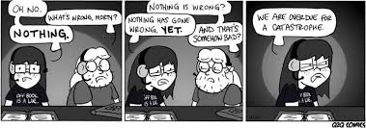
Sunday | Monday | Tuesday | Wednesday | Thursday | Friday | Saturday
 |  |  |  | 1 | 2 | 3
4 | 5 | 6 | 7 | 8 | 9 | 10
 | LABOR DAY
11 | 12 | 13 | 14 | 15 | 16 | 17
 |  |  | PARENT MEETING of  (Levels 2,34)  7 p.m. | PARENT MEETING of  (Level 1)  7 p.m.
18 | 19 | 20E | 21 | 22 | 23 | 24
25 | 26 | 27 | 28 | 29 | 30
WCSPA
Booster Club:
Gillespie Thr.
7pm

October
2022 | 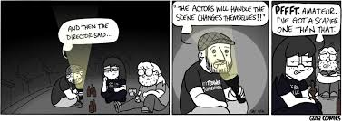
Sunday | Monday | Tuesday | Wednesday | Thursday | Friday | Saturday
 |  |  |  |  |  | 1
2 | 3 | 4E | COUNT DAY 5 | 6 | 7 | 8
 | AUDITION WEEK | AUDITION WEEK | AUDITION WEEK | AUDITION WEEK | AUDITION  WEEK
9 | 10 | 11 | 12 | 13 | 14 | 15
16 | 17 | 18E | 19 | 20 | 21 | 22
WCSPA Booster Club:
Roger’s Roost
7pm
23 | 24 | 25 | 26 | 27 | Q1 END 28 | 29
LOAD IN
SHAKES
30 | 31

November
2022 | 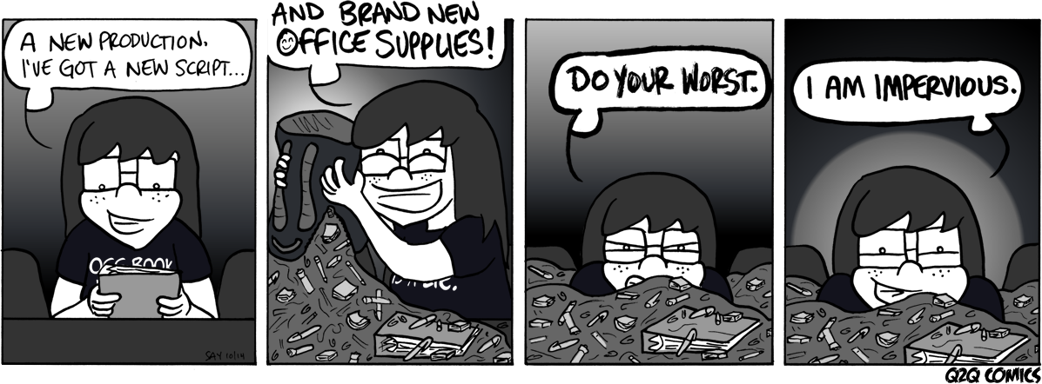
Sunday | Monday | Tuesday | Wednesday | Thursday | Friday | Saturday
 |  | 1E | 2 | 3 | 4 | 5
 |  | AD CAMP. END
6 | 7 | 8 | 9 | 10 | 11 | 12
 | LIGHT HANG | ELECTION DAY | SHAKES NIGHT  SCENIC LOAD IN | SHAKES NIGHT  SCENIC LOAD IN | SPACING | FOCUS
13 | 14 | 15 | 16 | 17 | 18 | 19
 | ACT 1 | ACT II | 1st DRESS | FINAL DRESS | SHE KILLS  MONSTERS | SHE KILLS  MONSTERS
20 | 21 | 22 | 23 | 24 | 25 | 26
 | -P.T CONF.  3p – 8 p  -WCSPA  Booster Club:  G Theatre-8pm | -P.T. CONF  12p – 6p | T H A | N K S G | I V I N G
27 | 28 | 29 | 30
WHITE MODEL
LVL 1 SHOW

December
2022 | 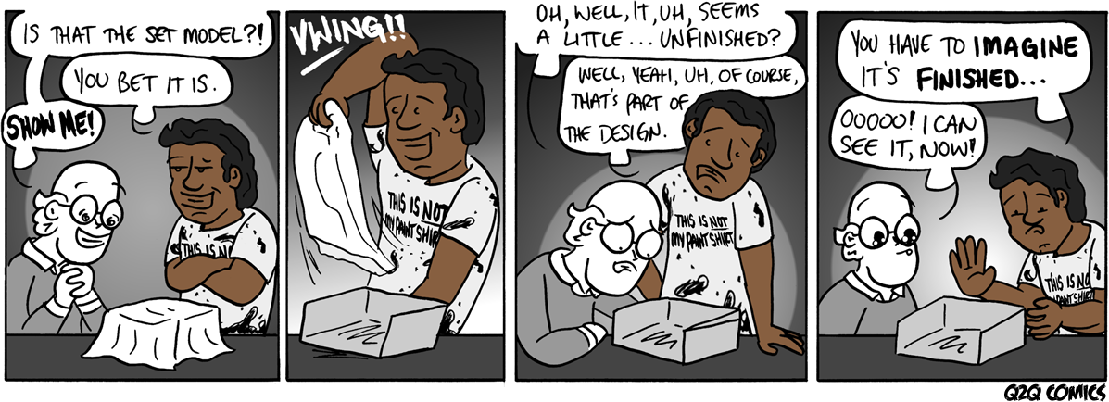
Sunday | Monday | Tuesday | Wednesday | Thursday | Friday | Saturday
 |  |  |  | 1 | 2 | 3
4 | 5 | 6E | 7 | 8 | 9 | 10
 | WCSPA  Booster Club:  -Make goodie bags for Festival  (G Theatre-7pm) | FESTIVAL SHOW |  | FESTIVAL | FESTIVAL | FESTIVAL
11 | 12 | 13 | 14 | 15 | 16 | 17
 |  | CAB AUDS  WHITE MODEL  BIG SHOW | CAB AUDS
18 | 19 | 20 | 21 | 22 | 23 | 24
25 | 26 | 27 | 28 | 29 | 30 | 31
 |  | H O L | I D A | Y B R | E A K

January
2023 | 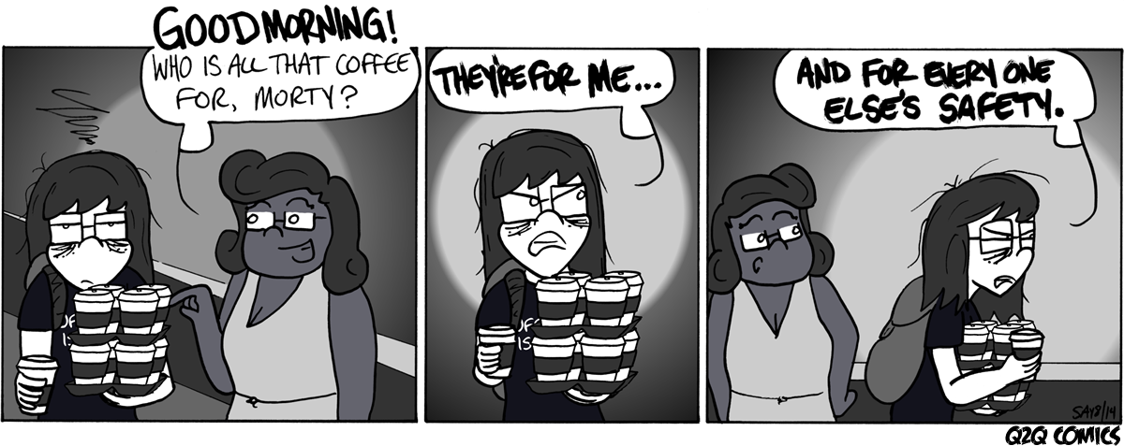
Sunday | Monday | Tuesday | Wednesday | Thursday | Friday | Saturday
1 | 2 | 3 | 4 | 5 | 6 | 7
8 | 9 | 10 | EXAMS 11 | EXAMS 12 | EXAMS/ Q2 END13 | 14
LVL 1
COLOR MODEL
15 | 16 | 17 | 18 | 19 | 20 | 21
 | MLK DAY  POETRY Perf.  NIGHT | TECH  STUDIO SHOW  AUD LVL1 | TECH  STUDIO SHOW  AUD LVL1 | TECH  STUDIO  AUD LVL1 | 12 ANGRY JURORS  AUD LVL1 | 12 ANGRY  JURORS
22 | 23 | 24E | 25 | 26 | 27 | 28
WCSPA
Booster Club:
Roger’s Roost
7 pm
29 | 30 | 31

February
2023 | 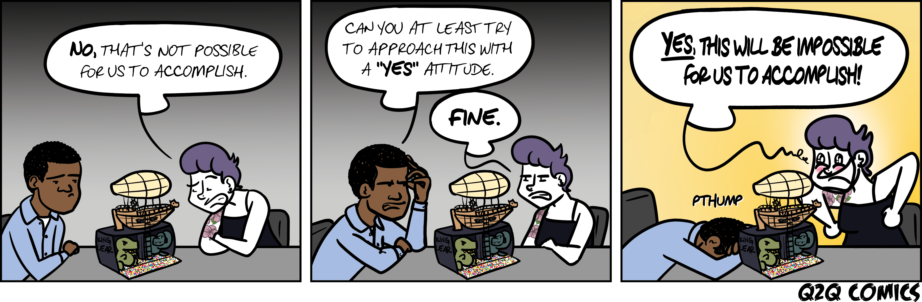
Sunday | Monday | Tuesday | Wednesday | Thursday | Friday | Saturday
 |  |  | 1 | 2 | 3 | 4
5 | 6 | 7E | COUNT DAY 8 | 9 | 10 | 11
 |  |  |  |  | LOAD IN  CABARET  STIZ PROBE | CABARET  7p / 9p
12 | 13 | 14 | 15 | 16 | 17 | 18
 | WCSPA  Booster Club:  G Theatre-7pm | COLOR MODEL  BIG SHOW
19 | 20 | 21 | 22 | 23 | 24 | 25
 |  | W I N | T E R | B R E | A K
26 | 27 | 28
 | TOUR REHEARSAL | TOUR REHEARSAL

March
2023 | 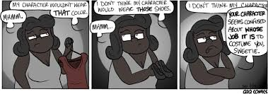
Sunday | Monday | Tuesday | Wednesday | Thursday | Friday | Saturday
 |  |  | 1 | 2 | 3 | 4
 |  |  | TOUR | TOUR | TOUR
5 | 6 | 7E | 8 | 9 | 10 | 11
 | AUDITIONS | AUDITIONS | AUDITIONS | AUDITIONS | AUDITIONS | LVL 1 22/23 AUD
12 | 13 | 14 | 15 | 16 | 17 | 18
 | LIGHT HANG  WCSPA  Booster Meeting:  -Notice of elections  -Roger’s Roost (7pm) | LIGHT HANG | SCENIC LOAD | SCENIC LOAD  PT. CONF  12 - 8 | STIZPROBE  SPACING  3 – 9 | FOCUS  9a – 4p
19 | 20 | 21E | 22 | 23 | Q3 END 24 | 25
 | TECH | TECH | DRESS | FINAL DRESS | NEWSIES | NEWSIES
26 | 27 | 28 | 29 | 30 | 31
NEWSIES MAT.
9:30 a & Noon
LOAD OUT

April
2023 | 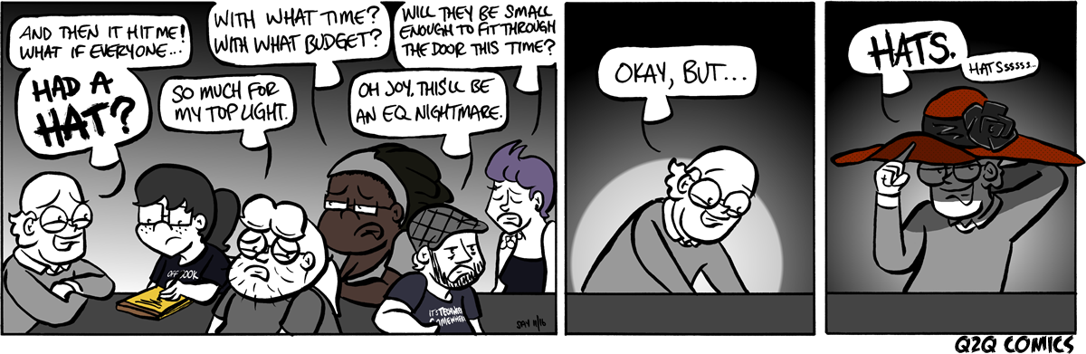
Sunday | Monday | Tuesday | Wednesday | Thursday | Friday | Saturday
 |  |  |  |  |  | 1
2 | 3 | 4 | 5 | 6 | 7 | 8
 | S | P R I | N G B | R E | A K
9 | TESTING 10 | TESTING 11 | TESTING 12 | TESTING 13 | TESTING 14 | 15
16 | 17 | 18E | 19 | 20 | 21 | 22
SHOP BIRTHDAY
WCSPA
Booster Club:
-Roger’s Roost-7pm
23 | 24 | 25 | 26 | 27 | 28 | 29
30

May
2023 | 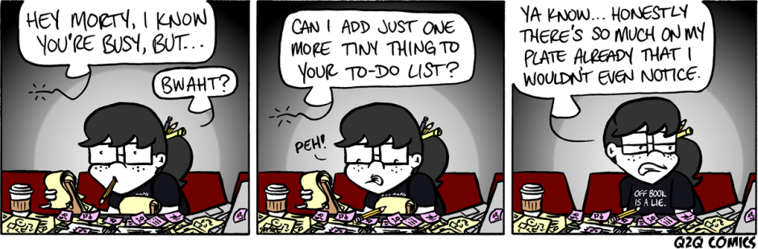
Sunday | Monday | Tuesday | Wednesday | Thursday | Friday | Saturday
 | 1 | 2 | 3 | 4 | 5 | 6
 |  | ELECTION DAY |  |  |  | LIGHT HANG
7 | 8 | 9 | 10 | 11 | 12 | 13
 | LIGHT HANG | STIZPROBE  3 – 9 | SCENIC LOAD | SCENIC LOAD | SPACING  3 - 9 | FOCUS
14 | 15 | 16E | 17 | 18 | 19 | 20
 | ACT I  3 - 10 | ACT II  3 - 10 | DRESS  3 - 10 | FINAL DRESS  3 -10 | FREAKY FRIDAY | FREAKY FRIDAY
21 | 22 | 23 | 24 | 25 | 26 | 27
FREAK FRIDAY  LOAD OUT | LOAD OUT  WCSPA  Booster Meeting:  -Elections  G Theatre-7pm
28 | 29 | 30 | 31
MEMORIAL
DAY

June
2023 | 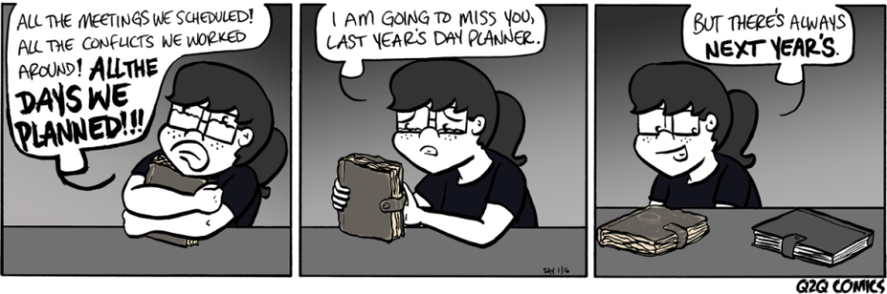
Sunday | Monday | Tuesday | Wednesday | Thursday | Friday | Saturday
 |  |  |  | 1 | 2 | GRAD 3
 |  |  |  | SENIOR SHOW
4 | 5 | 6 | 7 | 8 | 9 | 10
 | WCSPA  Booster Meeting:  -Roger’s Roost (7pm) |  | BANQUET
11 | 12 | EXAM 13 | EXAM 14 | EXAM 15 | 16 | 17
 | WCSPA FINALS
18 | 19 | 20 | 21 | 22 | 23 | 24
25 | 26 | 27 | 28 | 29 | 30

July
2023 | 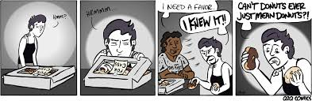
Sunday | Monday | Tuesday | Wednesday | Thursday | Friday | Saturday
 |  |  |  |  |  | 1
2 | 3 | 4 | 5 | 6 | 7 | 8
9 | 10 | 11 | 12 | 13 | 14 | 15
16 | 17 | 18 | 19 | 20 | 21 | 22
23 | 24 | 25 | 26 | 27 | 28 | 29
30 | 31

August
2023 | 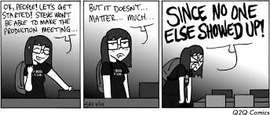
Sunday | Monday | Tuesday | Wednesday | Thursday | Friday | Saturday
 |  | 1 | 2 | 3 | 4 | 5
6 | 7 | 8 | 9 | 10 | 11 | 12
13 | 14 | 15 | 16 | 17 | 18 | 19
20 | 21 | 22 | 23 | 24 | 25 | 26
27 | 28 | 29 | 30 | 31

